**EXPERIMENT-5**

**AIM:** To find the wavelength of He-Ne laser source using transmission diffraction grating

**APPARATUS:** Laser Source with its holder, diffraction grating with its mount, screen, scale and optical bench

**THEORY:** When monochromatic radiation of wavelength ‘lambda’ is diffracted by diffraction grating then the nth order principal maxima if formed at angle ‘theta’ given by: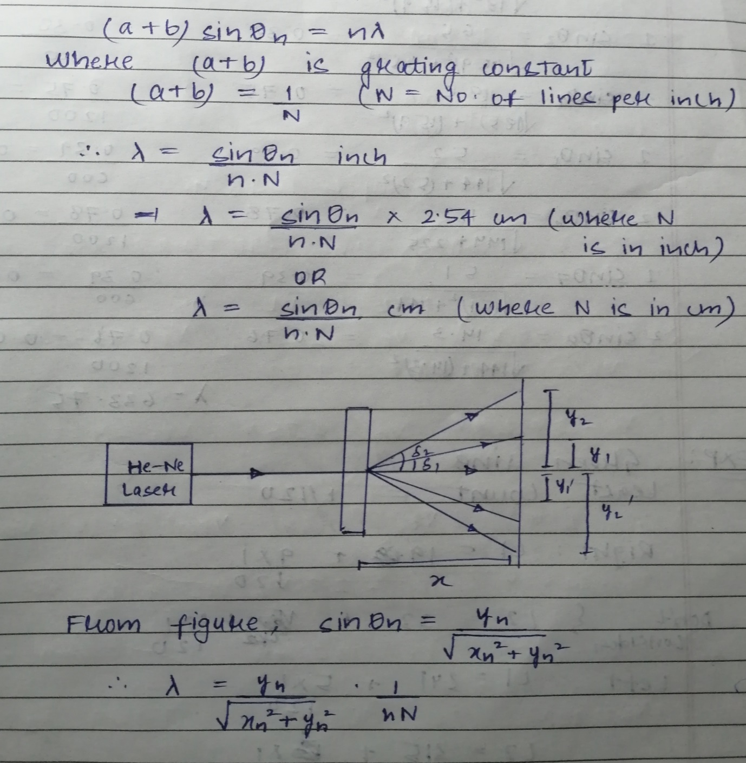

**OBSERVATION:** Grating sheet=600 lines/mm

Wavelength of he-ne laser(actual) = 632.8nm

|  |  |  |  |  |  |  |
| --- | --- | --- | --- | --- | --- | --- |
| S. No | Order of diffraction(n) | Position of screen(x) | Distance from central spot | | Sin(theta) | |
|  |  |  | Right | Left | Right | Left |
| 1. | 1 | 15.9cm | 6.2cm | 6.5cm | 0.36 | 0.38 |
| 2. | 2 | 15.9cm | 18cm | 18.5cm | 0.74 | 0.75 |
| 3. | 1 | 12cm | 5.2cm | 5.1cm | 0.39 | 0.39 |
| 4. | 2 | 12cm | 15cm | 14.3cm | 0.78 | 0.76 |

**CALCULATIONS:**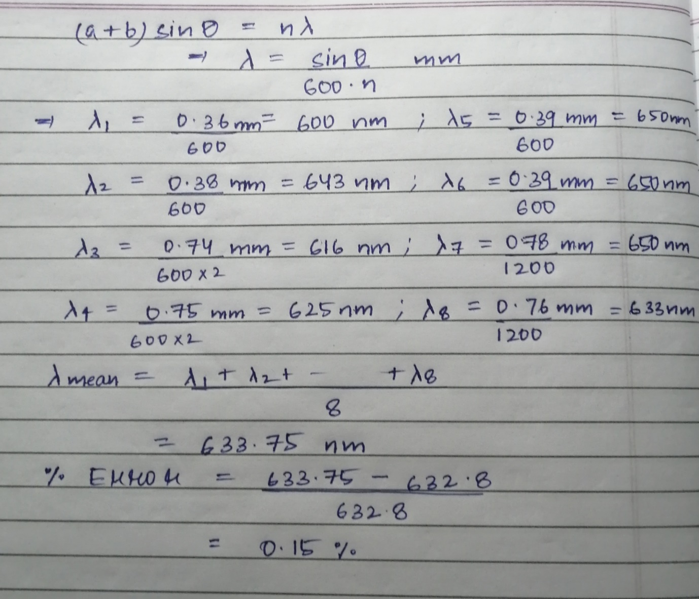

**RESULT:** The wavelength of he-ne laser light is 633.75nm.

Percentage error is 0.15%.

**PRECAUTIONS:** 1) Never stare directly at the laser source, it may damage your eyes.

2) Before switching on the laser source, the system must be properly aligned.

3) Laser should neither be too close nor too far from the screen.

**By: Amogh Garg**

**2020UCO1688**

**COE(Section-3)**